When a page loads-

High-level aspects of loading a webpage:

1. You enter [**www.networkcomputing**](http://www.networkcomputing/) into your browser address bar
2. Your computer needs to use ARP to resolve its router IP address to a MAC address
3. Resolve the domain name to an IP address
4. Load the main web page and process any php, CSS, or other commands
5. As the page loads, there will be references to other domain names
6. Resolve other domain names
7. Rinse and repeat ;)

Page load time chrome extension-

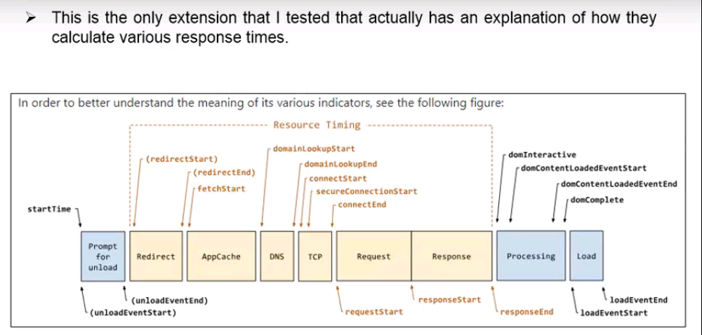

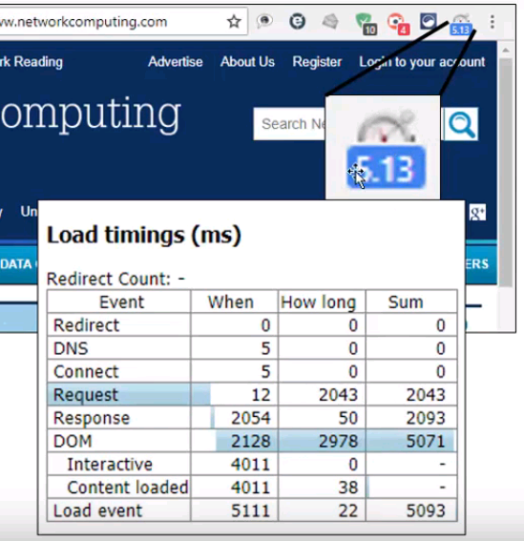

For using this extension, follow steps-

1. I installed the **Chrome Page Load Time** [**extension**](https://chrome.google.com/webstore/detail/page-load-time/fploionmjgeclbkemipmkogoaohcdbig) or search for Page Load Time
2. Start Chrome and load the page you want to test and wait for it to load
3. Clear your Chrome temporary files by pressing Ctrl+Shift+Del, check the **Cached images and files** and click **Clear Data**
4. Go to command prompt as administrator and clear arp cache ***arp –d***
5. Clear DNS cache ***ipconfig /flushdns***
6. Press the Refresh icon or F5
7. Record time reported by the extension
8. Repeat Steps